**Testing Concepts**

Lesson 04: Test Management & Test Case Execution

Test Planning:

**Test Plan:** A document Describing the Scope, approach, resources and schedule of the intended test activities. It identifies, amongst other, test items, the features to be tested, the testing task, the degree of tester independence, the test environment, the test design technique, the entry exit criteria to be used and the rationale for their choice and any risk requiring contingency planning. it is record of the test planning process. The Test Plan contents are listed below:

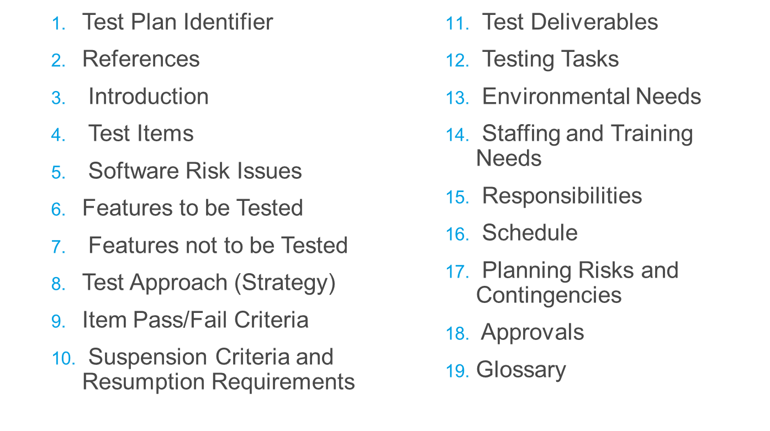

Pre-execution activities:

Setting up the Environment similar to production environment

* Hardware (e.g. Hard Disk, RAM, Processor)
* Software (e.g. IE, MS office)
* Access to Applications
* Setting up data for Execution
* Any format (e.g. xml test data, system test data, SQL test data)
* Create fresh set of your own test data, or use existing sample test data

Types of Test Environment:

* Unit Test Environment
* Assembly/Integration Test Environment
* System/Functional/QA Test Environment
* User Acceptance Test Environment
* Production Environment

Test Case Execution:

**Run Tests**

* Run test on the identified Test Bed
* Precondition
* Use the relevant test data

**Note the Result**

* Objective of test case
* Action performed
* Expected outcome
* Actual outcome
* Pass/Fail (according to pass/fail criteria)

**Compare the Input and Output**

* Validate the data (e.g. complex scenarios, data from multiple interfaces)

**Record the Execution**

* Test data information (e.g. type of client, account type)
* Screenshots of the actions performed and results
* Video recording (HP QC Add-in)

Test Estimation Techniques:

Estimating the efforts required for testing is one of the major and important tasks in SDLC. Correct estimation helps in testing the software with maximum coverage. Software Testing Estimation Techniques:

* **Work breakdown structure (WBS)** – Breaking down the large activities and tasks into smaller, more manageable tasks.
* **Bottom-up estimation** - Estimate for efforts, duration, dependencies etc for lowest level tasks from WBS and roll-up to arrive total estimate
* **Top-down estimation** - Deriving estimates from similar projects
* **Parametric technique** – Estimating based on some parameters. E.g. average effort per test case

Roles & Responsibilities - Working as a Tester:

Review and contribute to test plans. Analyze, review and assess user requirements, specifications and models for testability. Create, review Test specifications. Set up the test environment. Define, prepare and acquire test data. Implement tests on all test levels, execute and log the tests. Evaluate the results and document the deviations (defects/issues) from expected results. Use various test tools as required. Automate tests